FIT2092- ASSIGNMENT 2 DOCUMENTATION

**Website Design & Development**

Group Members:

26254883- Fransisca F Kisanaga

28233654- Henrick Huynh

Table of Contents:

Scheduling 3

Brief Analysis 3

Task Allocation 3

Concept Development and Refinement 4

Development & Changes 5

Overall Changes Summary 7

References:

Photos 8

Online Tutorials Used 13

**SCHEDULING**

|  |  |  |  |  |  |  |  |
| --- | --- | --- | --- | --- | --- | --- | --- |
|  | Monday | Tuesday | Wednesday | Thursday | Friday | Saturday | Sunday |
| Week 7  (3-9 September) | SCHEDULING  BRIEF ANALYSIS | CONCEPT DEVELOPMENT & REFINEMENT | TASK ALLOCATION  CONCEPT DEVELOPMENT & REFINEMENT | DEVELOPMENT | DEVELOPMENT |  |  |
| Week 8  (10-14 September) | DEVELOPMENT | DEVELOPMENT | DEVELOPMENT | DEVELOPMENT | REFINEMENT  DELIVERY  DEADLINE (5PM) |  |  |

**BRIEF ANALYSIS**

This assignment is the continuous from assignment 1: pre-production documentation to develop and design an interactive website from the client brief. Using JavaScript, CSS Animations and Audio/Video media that we learnt during the 8 weeks’ worth of tutorial to be apply on the design and the development of the website.

**TASK ALLOCATION**

Work was divided exactly as planned. Henrick focused on developing the HTML, CSS, and JavaScript/jQuery portions of the project while Fransisca was more responsible for the creation and editing of media and content. However, also as noted previously, both team members frequently performed tasks from the opposite areas and aided each other when difficulties were encountered.

**CONCEPT DEVELOPMENT & REFINEMENT**

Navigation (All pages)-Javascript

Reference:

<https://moodle.vle.monash.edu/pluginfile.php/7325784/mod_resource/content/6/Tutorial%206.pdf>

Page 1- Video Media, Javascript - aos

Reference: <https://moodle.vle.monash.edu/pluginfile.php/7272210/mod_resource/content/1/Tutorial%201.pdf>

Page 2- CSS Animation - CSS keyframe Animation & CSS Sprite Animations, Javascript - aos

2 animations - syringe & dna

Reference: <https://moodle.vle.monash.edu/pluginfile.php/7318457/mod_resource/content/2/Tutorial%203.pdf>

Page 3- JavaScript- aos & JQuery- lightbox effects

Reference:

<https://moodle.vle.monash.edu/pluginfile.php/7325806/mod_resource/content/1/Tutorial%207.pdf>

<https://moodle.vle.monash.edu/pluginfile.php/7297453/mod_resource/content/0/Tutorial%202.pdf>

Page 4- CSS Animation- & JavaScript - aos

Reference:

<https://moodle.vle.monash.edu/pluginfile.php/7318457/mod_resource/content/2/Tutorial%203.pdf>

Page 5- JavaScript- JQuery to interact with HTML5 forms, Video Media

Reference: <https://moodle.vle.monash.edu/pluginfile.php/7325866/mod_resource/content/1/Tutorial%208.pdf>

**DEVELOPMENT & CHANGES**

**Page 1:**

The original design of the 1st page changed. The logo has transparent background instead of the black background. Furthermore, the main logo is now in the middle. Whilst the navigation bar is more towards the left side with different headings title. In addition, the background video change as well to be darker and blending with the background colour. 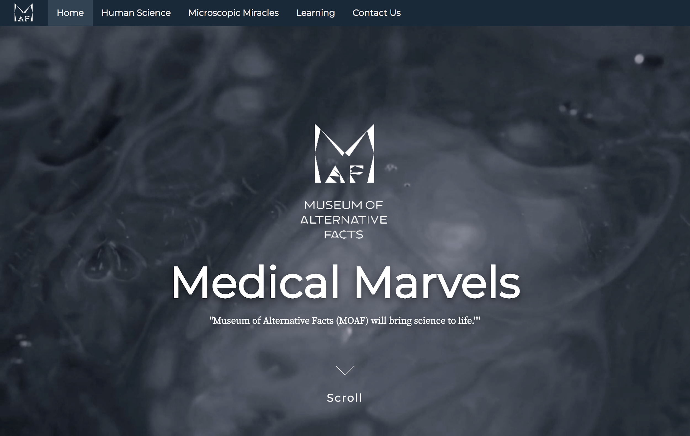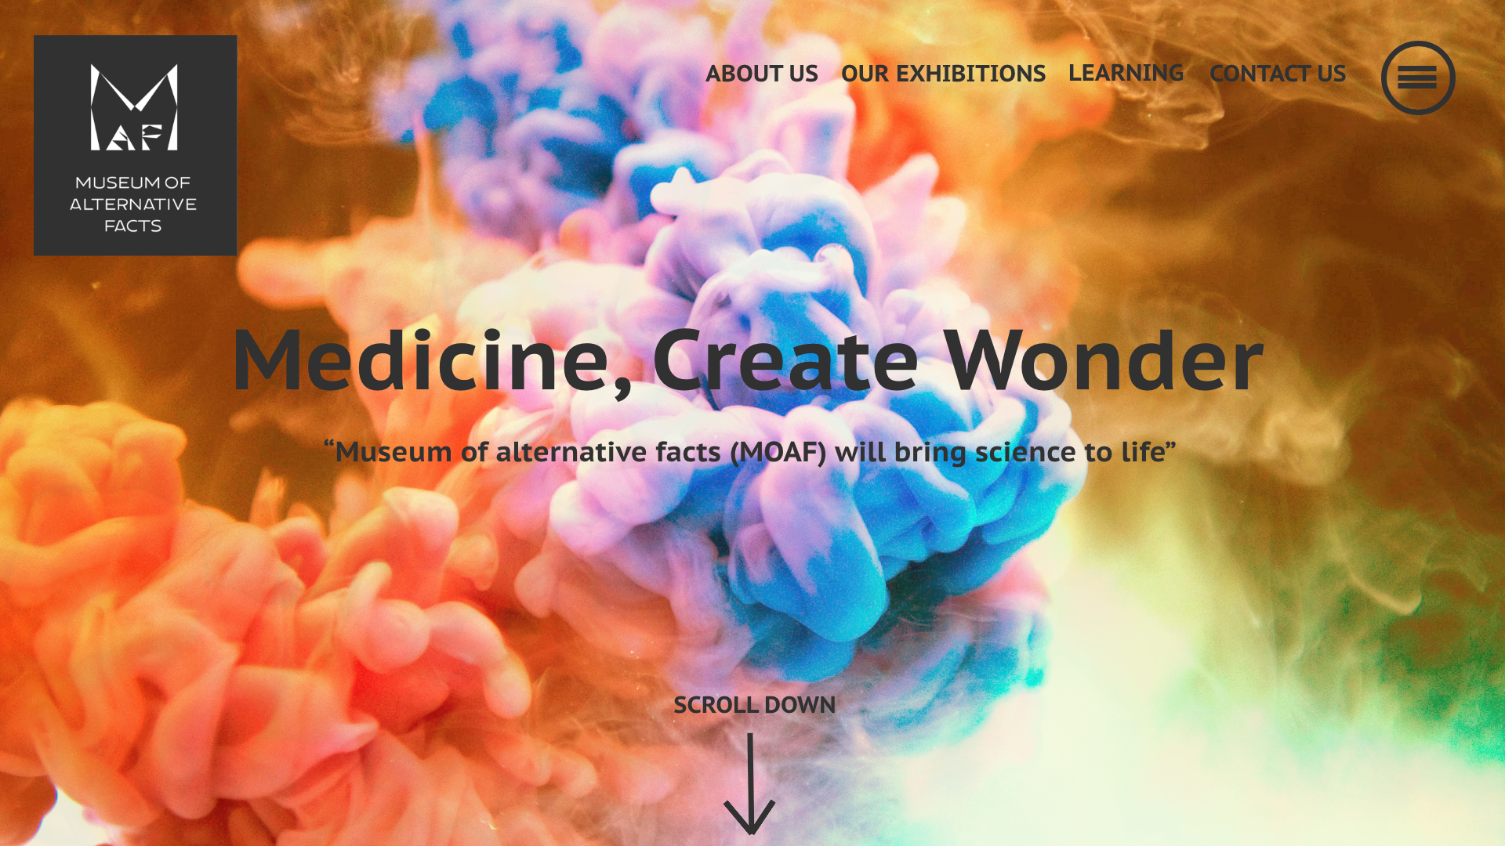

**Page 2:**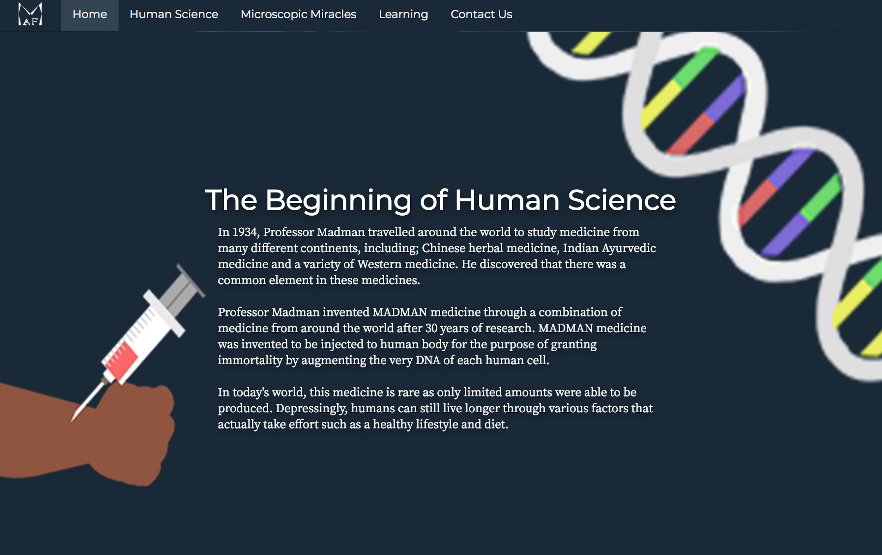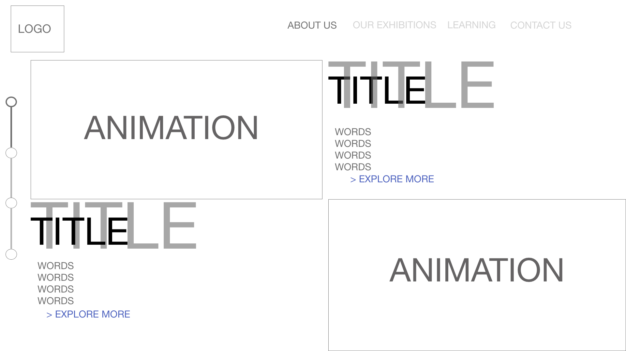

The 2nd page design changes as well. Firstly, we deleted the right-side nav bar but still keeping the top nav bar. Then, instead of 2 titles, we created 1 title with the background story with interacting pictures around it.

**Page 3:**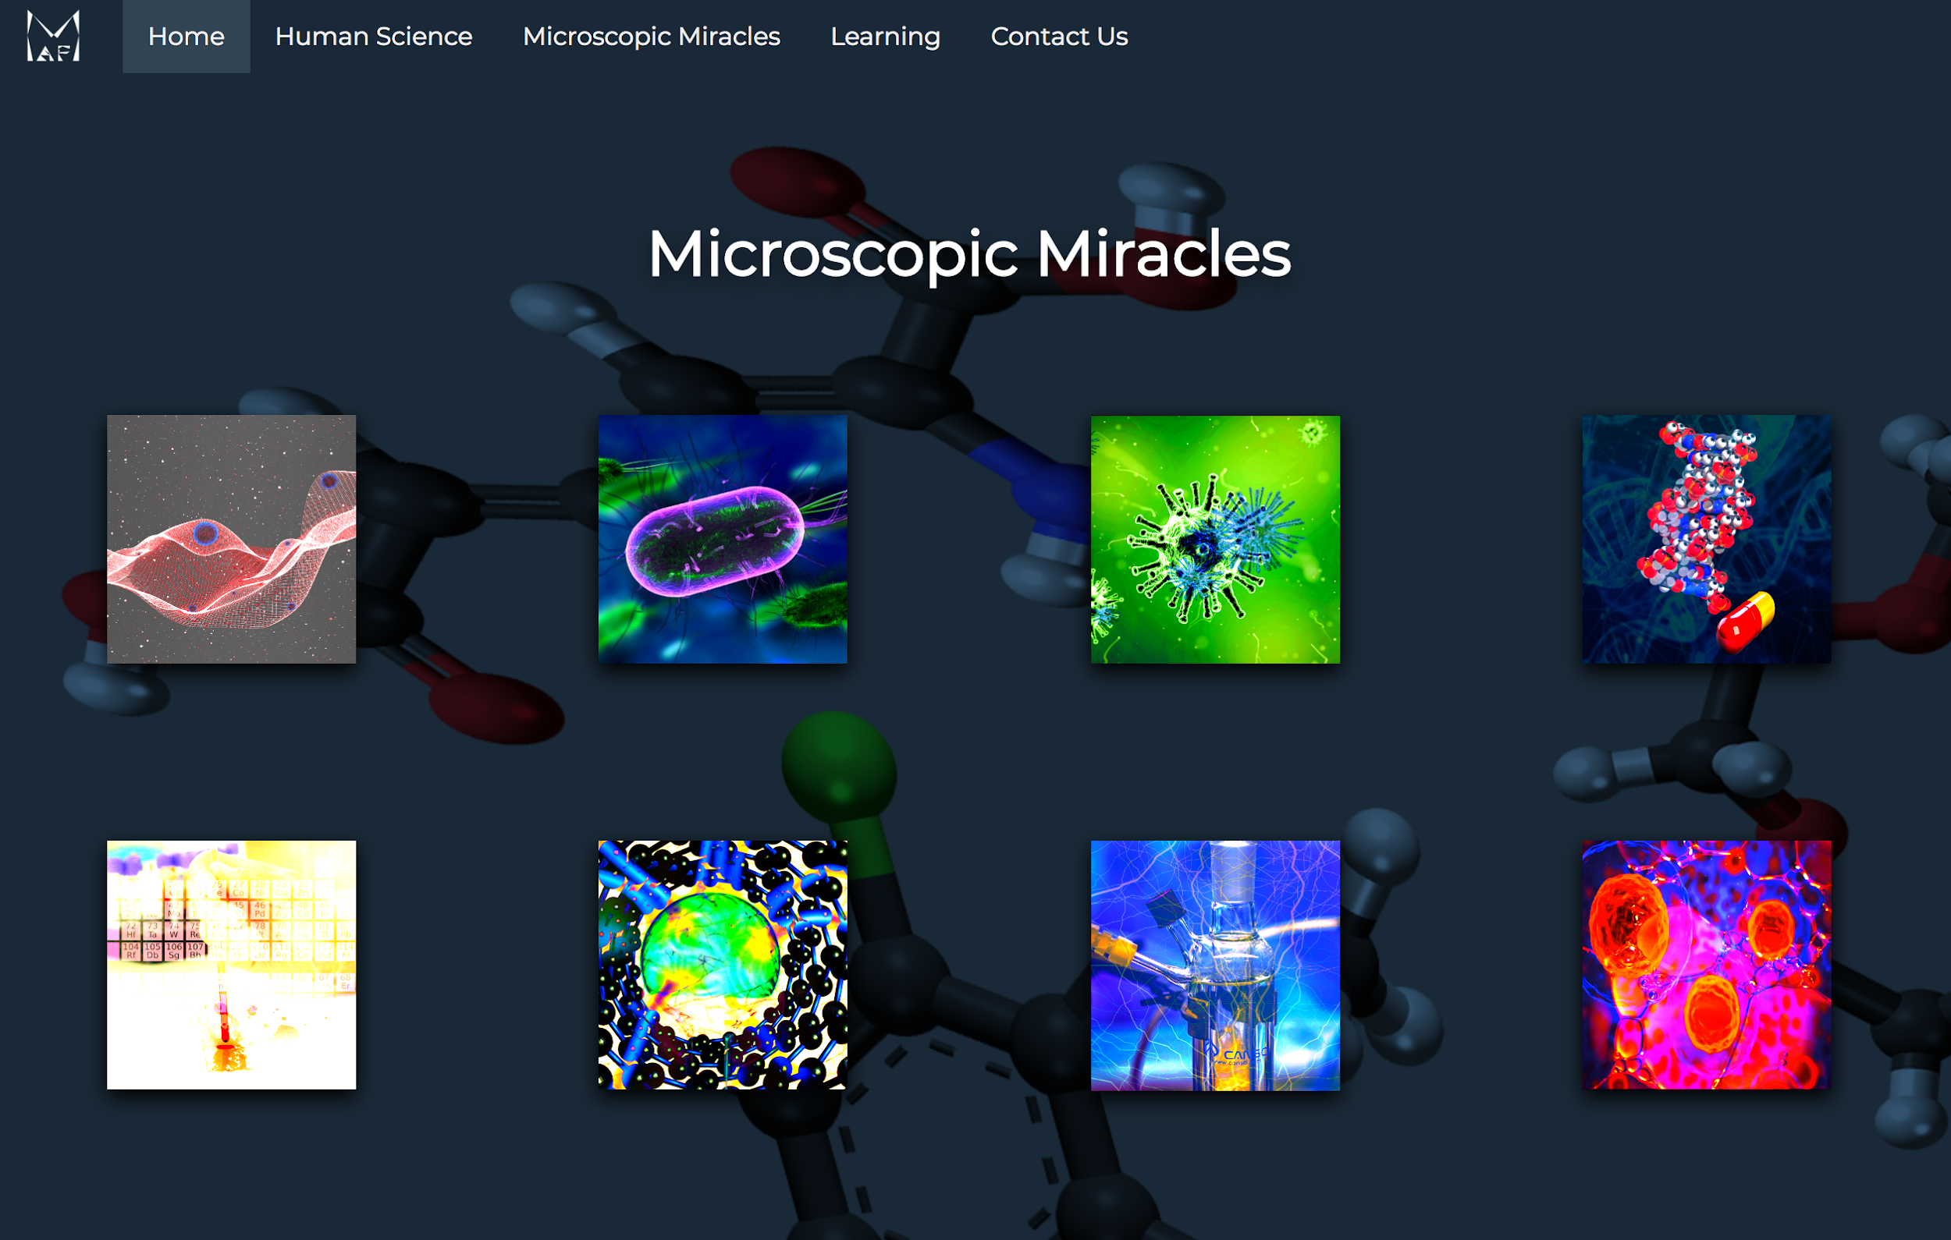

The 3rd page theme stay (showcase different pictures) however the animation of the pictures change from our original planned - this is because we learnt this animation and Javascript later after the assignment 1. The location of the pictures changes as well, more organised and there is different background compared to other slides.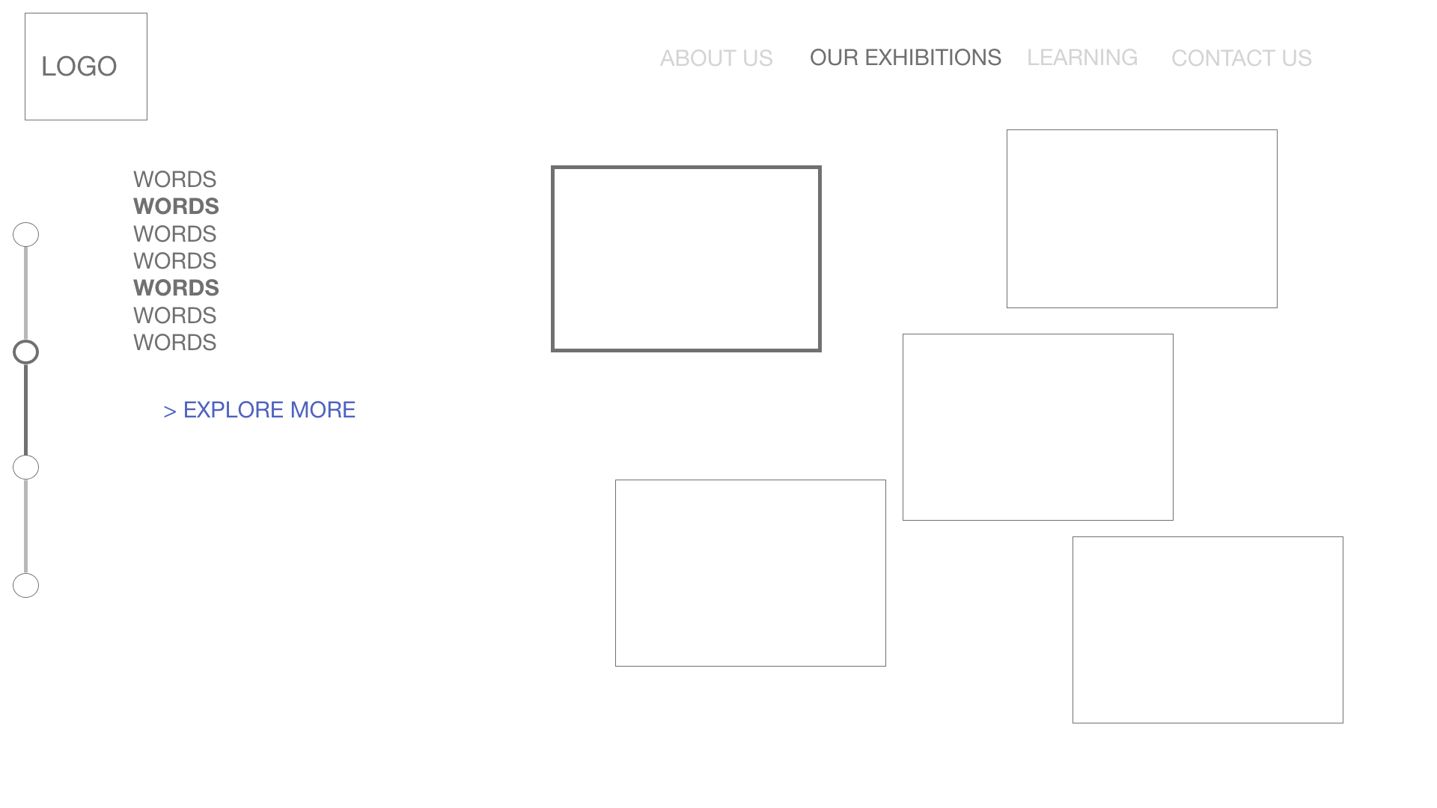

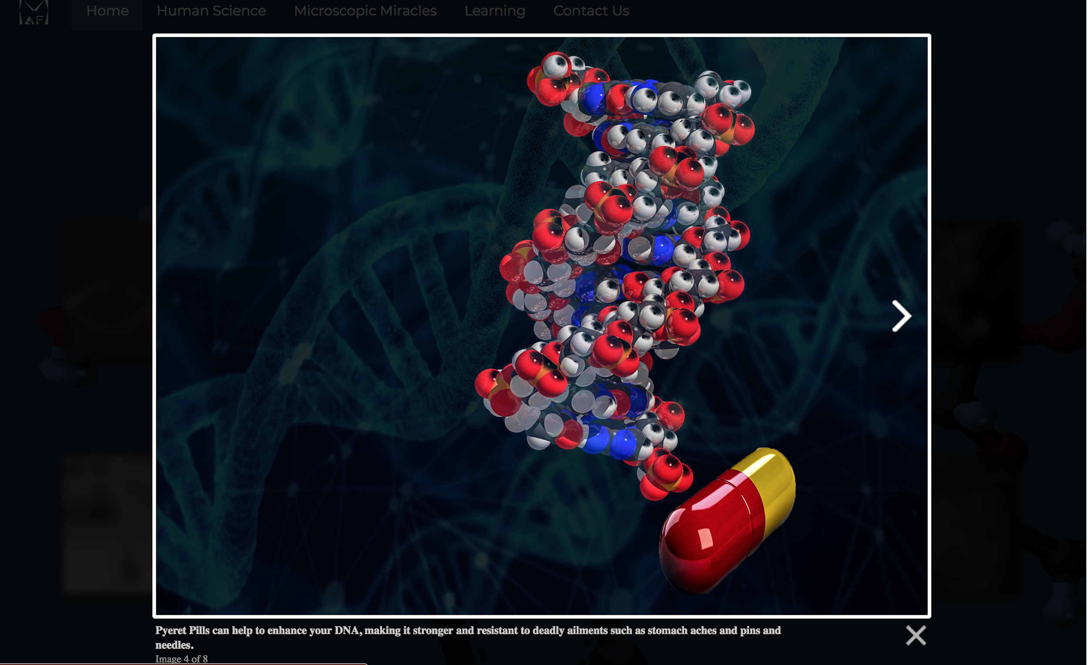

The animation changes: from each picture selected will highlight the associate words beside it to each picture selected, it will show bigger pictures with little description about it.

**Page 4:**

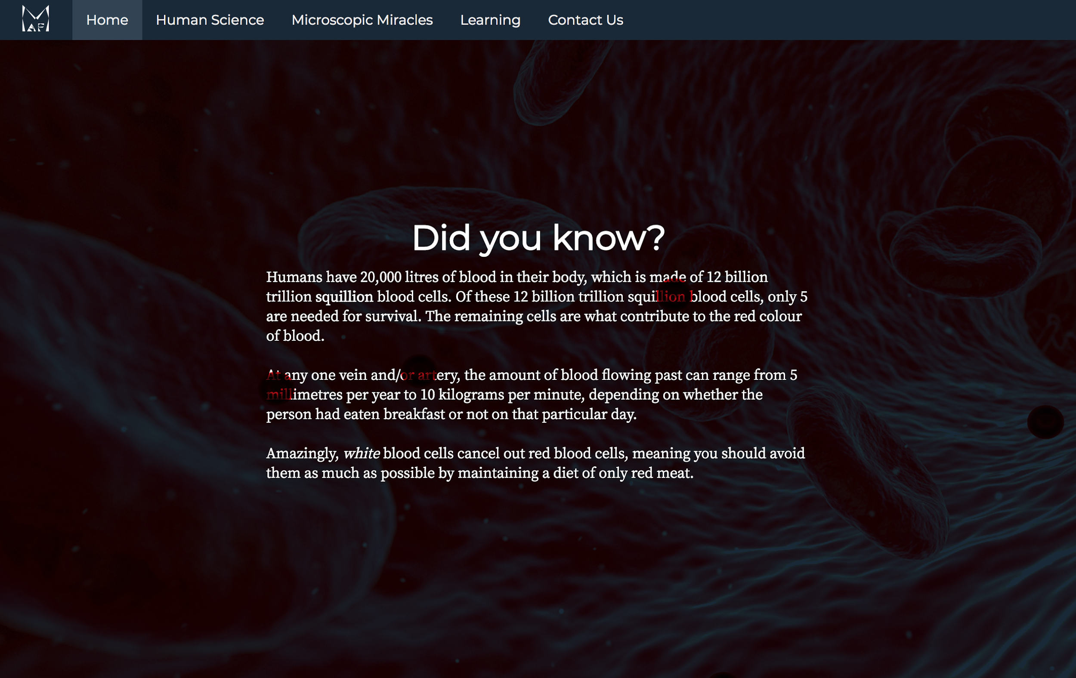

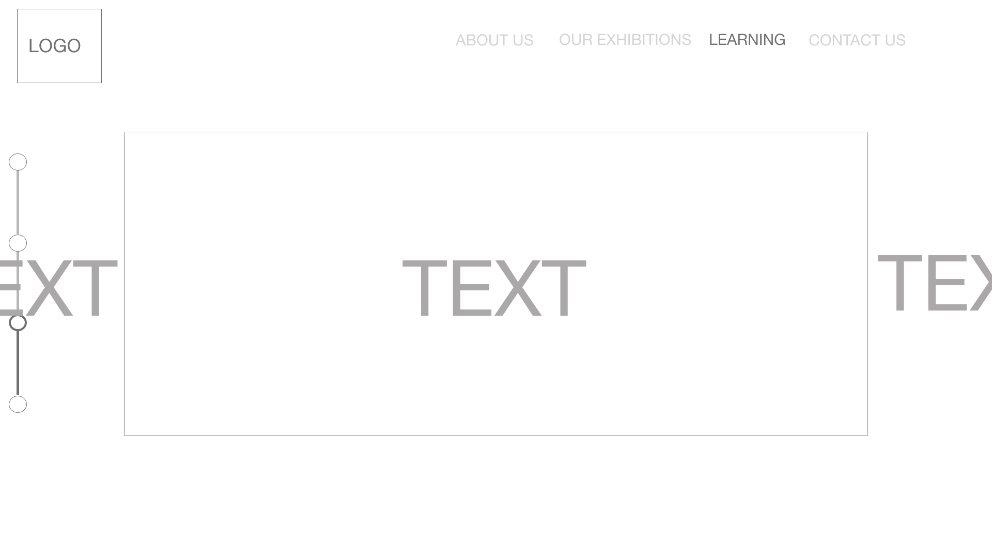

The 4th page, we change the most. Instead of having a slideshow and a text in middle that changes with the picture, we created an animation of the red blood cell moving around left to right of the text using @keyframes.

**Page 5:**

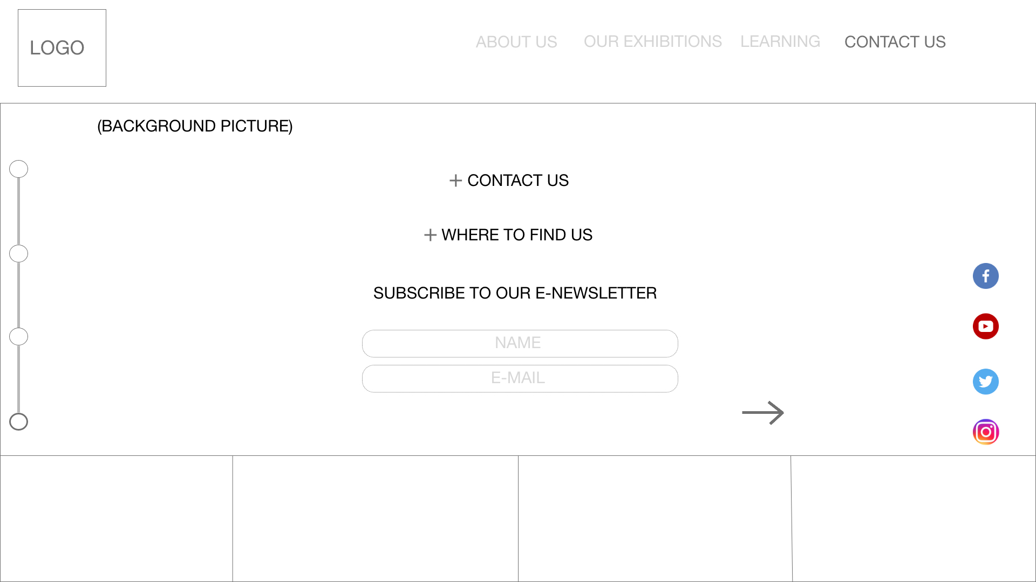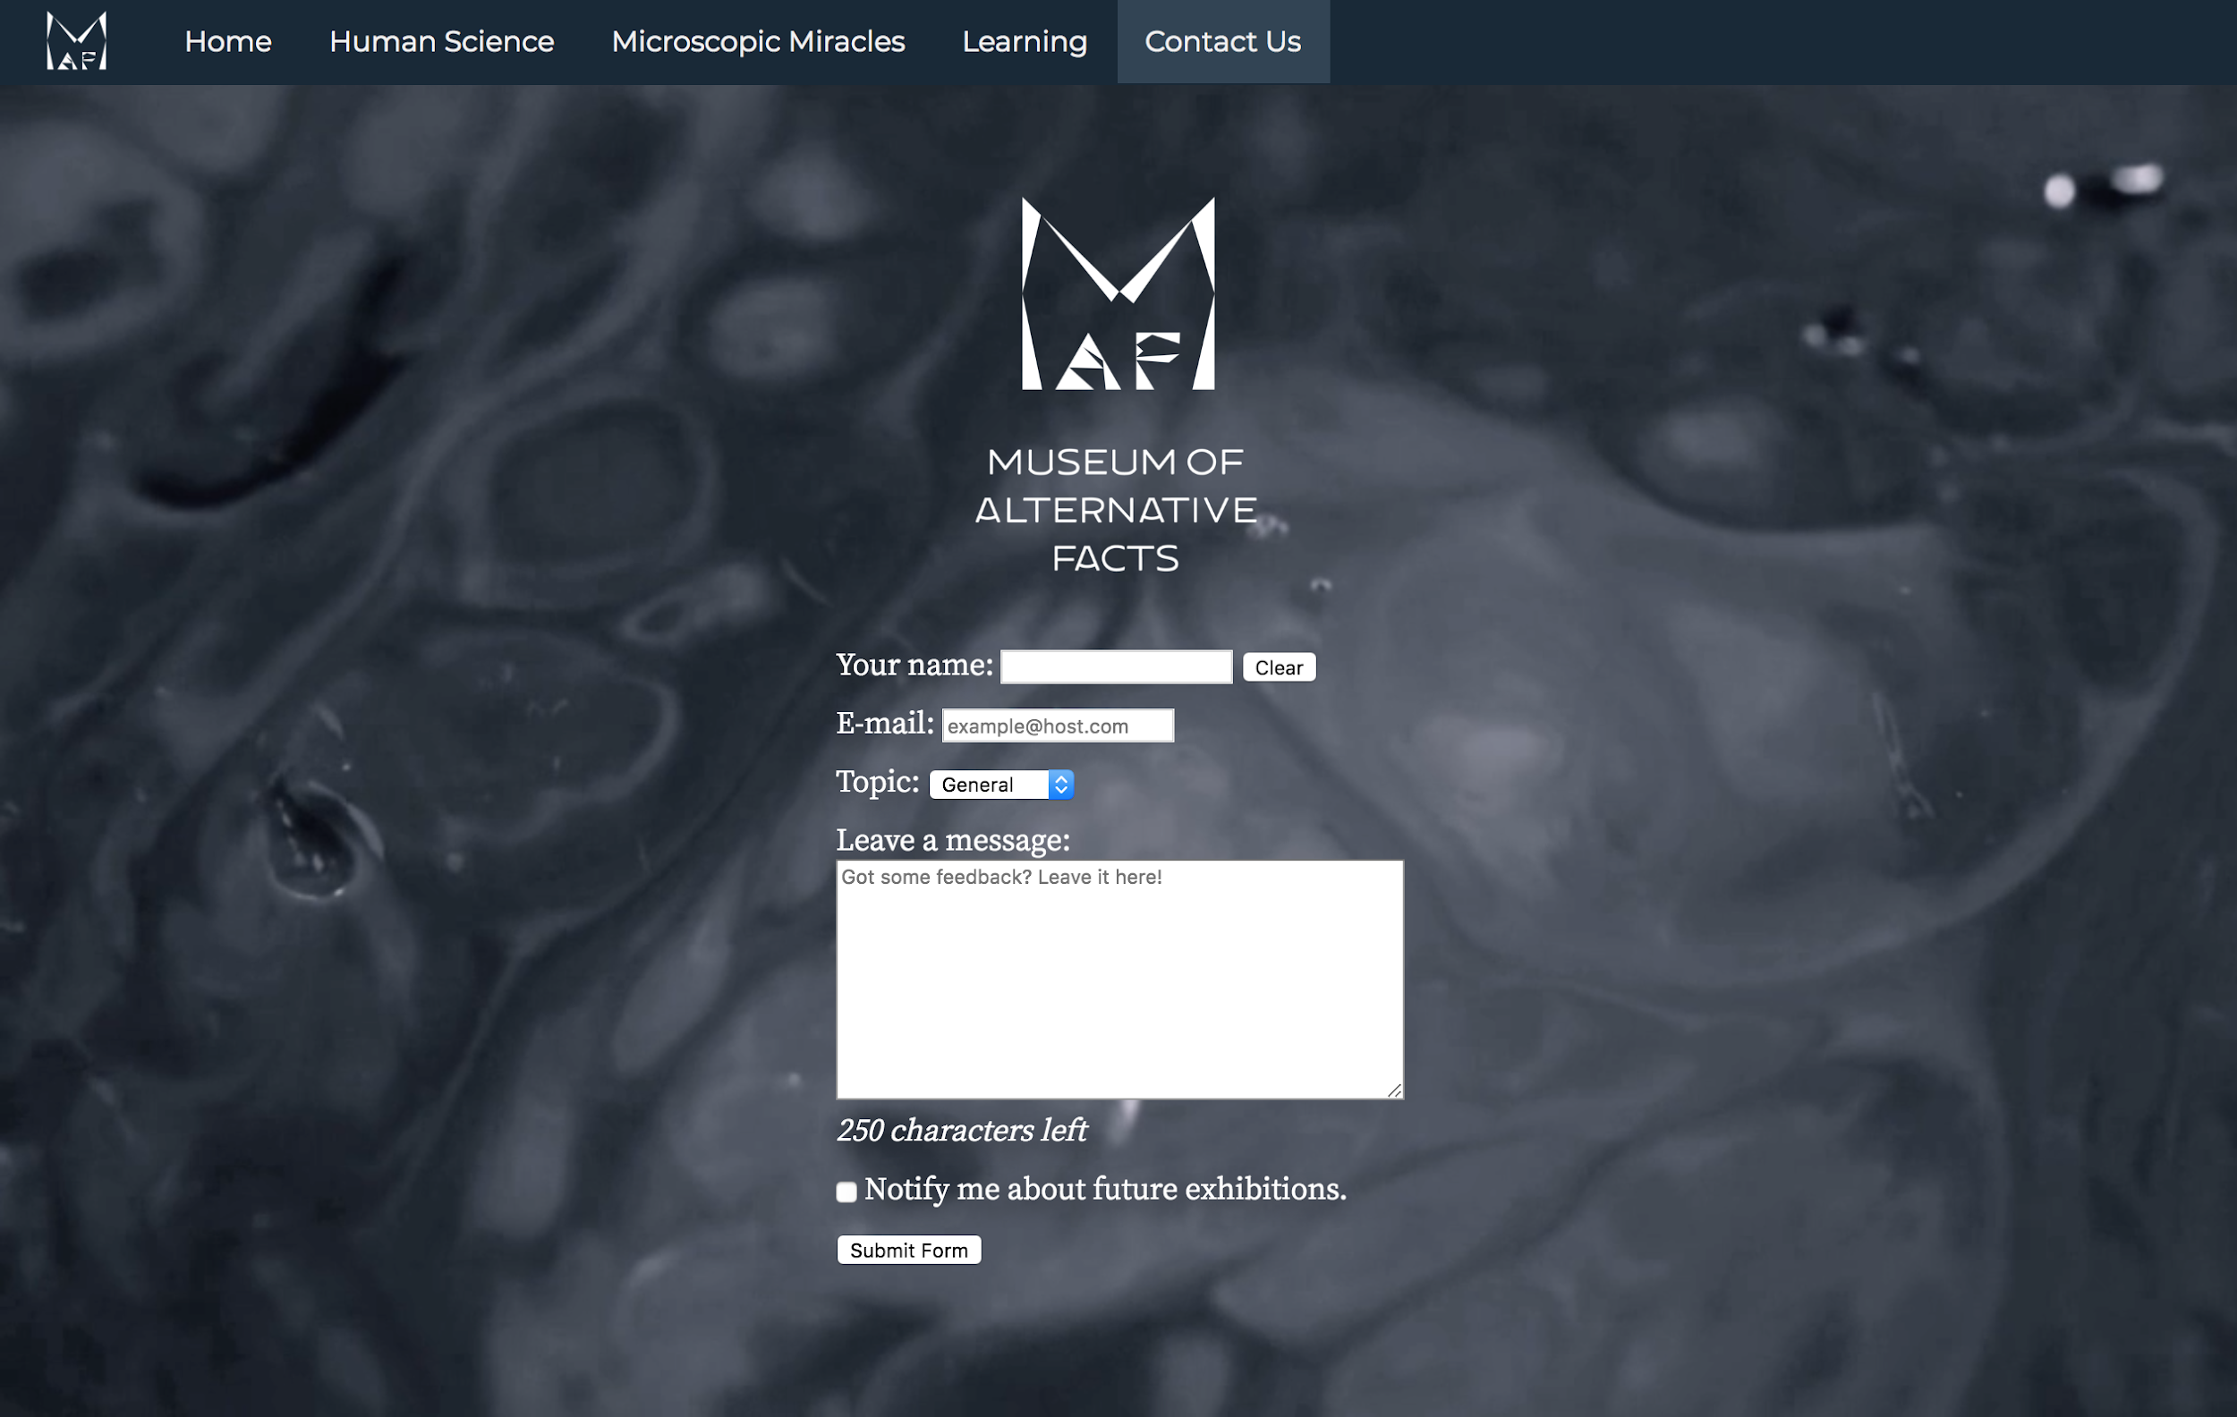

The 5th page, we did not put more picture at the bottom that connected to other pictures from the slide that the user has open. Instead, we just used the same looping videography as the first homepage as the whole background. The forms are more well-designed with the questionnaire.

**OVERALL CHANGES FROM THE ASSIGNMENT 1 PLANS**

The original was mostly adhered to; however, some minor changes were made. The most significant of these was the removal of the navigation module on the left-hand side. This was done as we found it unnecessary and made the page cluttered. Its functionality is included in the top constant navigation bar regardless. The other change was the removal of the carousel on page 4. We found that the planned format for the page did not facilitate the content well, and instead opted for a large 1 topic format with CSS animation. Overall, the design of the website changes the most due to limitation of skills and knowledge.

**REFERENCES:**

**PHOTOS USED**

|  |  |
| --- | --- |
| **Original (with reference)** | **Edited** |
| File/Original: Pexels Videos 1245509.mp4  URL: https://videos.pexels.com/videos/blood-cells-1245509  Author: videographer of pexels videos  License: | Used: Slide 1 and 5- Background Video |
| File/Original: bacteria-106583_1920.jpg  URL: https://pixabay.com/en/bacteria-virus-bacterial-species-106583/  Author: geralt of Pixabay  License:    File/Original: bacteria-1832824_1280.png  URL: https://pixabay.com/en/bacteria-bacterium-microbiology-1832824/  Author: sbtlneet of Pixabay  License: | Used: Slide 3 in one of the JQuery box. |
| File/Original: universe-3441033_1920.jpg  URL: https://pixabay.com/en/universe-space-connection-wave-3441033/  Author: TheDigitalArtist of Pixabay  License:    File/Original: bacteria-163711_1280.jpg  URL: https://pixabay.com/en/bacteria-illness-virus-infection-163711/  Author: PublicDomainPictures of Pixabay  License: | Used: Slide 3 in one of the JQuery box. |
| File/Original: bubbles-chemistry-close-up-220989.jpg  URL: https://www.pexels.com/photo/bubbles-chemistry-close-up-color-220989/  Author: Pixabay of Pexels  License:    File/Original: cells-1872666_1920.jpg  URL: https://pixabay.com/en/cells-human-medical-biology-health-1872666/  Author: qimono of Pixabay  License: | Used: Slide 3 in one of the JQuery box. |
| File/Original: virus-213708_1280.jpg  URL: https://pixabay.com/en/virus-infection-cell-bacterium-213708/  Author: PublicDomainPictures of Pixabay  License:    File/Original: virus-1812092_1920.jpg  URL: https://pixabay.com/en/virus-microscope-infection-illness-1812092/  Author: qimono of Pixabay  License: | Used: Slide 3 in one of the JQuery box. |
| File/Original: pill-1884775_1920.jpg  URL: https://pixabay.com/en/pill-capsule-medicine-medical-1884775/  Author: qimono of Pixabay  License:    File/Original: dna-694798_1920.jpg  URL: https://pixabay.com/en/dna-double-helix-model-minor-groove-694798/  Author: skeeze of Pixabay  License:    File/Original: dna-3539309_1920.jpg  URL: https://pixabay.com/en/dna-genetic-material-helix-proteins-3539309/  Author: geralt of Pixabay  License: | Used: Slide 3 in one of the JQuery box. |
| File/Original: carbon-nanotube-2842389_1280.jpg  URL: https://pixabay.com/en/carbon-nanotube-bucky-graphene-2842389/  Author: cintersimone of Pixabay  License:    File/Original: blur-charge-close-up-256302.jpg  URL: https://www.pexels.com/photo/close-up-view-of-plasma-256302/  Author: Pixabay of Pexels  License:    File/Original: flash-3604926_1920.jpg  URL: https://pixabay.com/en/flash-electricity-energy-current-3604926/  Author: geralt of Pixabay  License: | Used: Slide 3 in one of the JQuery box. |
| File/Original: lab-1825276_1920.jpg  URL: https://pixabay.com/en/lab-chemical-science-research-1825276/  Author: jdn2001cn0 of Pixabay  License:    File/Original: flash-3604926_1920.jpg  URL: https://pixabay.com/en/flash-electricity-energy-current-3604926/  Author: geralt of Pixabay  License: | Used: Slide 3 in one of the JQuery box. |
| File/Original: blood-17305_1920.jpg  URL: https://pixabay.com/en/blood-sample-lab-laboratory-17305/  Author: PublicDomainPictures of Pixabay  License:    File/Original: ink-303244_1280.png  URL: https://pixabay.com/en/ink-red-splatter-abstract-paint-303244/  Author: Clker-Free-Vector-Images of Pixabay  License:    File/Original: periodic-system-1059755_1920.png  URL: https://pixabay.com/en/periodic-system-chemistry-science-1059755/  Author: geralt of Pixabay  License: | Used: Slide 3 in one of the JQuery box. |
| File/Original: blood-1813410_1920.jpg  URL: https://pixabay.com/en/blood-cells-red-medical-medicine-1813410/  Author: qimono of Pixabay  License: | Used: Slide 4 as background image. |
| File/Original: red-blood-cell-1861640_1920.png  URL:<https://pixabay.com/en/red-blood-cell-rbc-erythrocyte-1861640/>  Author: sbtlneet of Pixabay  License: | Used: Slide 4 as CSS Animation @keyframes |
| File/Original: dna-3500555.svg  URL: https://pixabay.com/en/dna-rna-strand-biology-school-3500555/  Author: janjf93 of Pixabay  License: | Used: Slide 2 as CSS Animation using Photoshop |
| File/Original: syringe-1597515.svg  URL: https://pixabay.com/en/syringe-doctor-needle-1597515/  Author: janjf93 of Pixabay  License:    File/Original: fist-1741100.svg  URL: https://pixabay.com/en/fist-hand-revolution-freedom-power-1741100/  Author: sinisamaric of Pixabay  License: | Used: Slide 2 as CSS Animation using Photoshop |

**ONLINE TUTORIALS**

Navbar

<https://www.w3schools.com/howto/howto_css_fixed_menu.asp>

<https://www.w3schools.com/css/css_navbar.asp>

Used for scrolling down button, removed navigation

<https://codepen.io/nxworld/pen/OyRrGy>